**Project Design Phase-II**

**Data Flow Diagram & User Stories**

|  |  |
| --- | --- |
| Date | 26-06-2025 |
| Team ID | LTVIP2025TMID53570 |
| Project Name | ShopEZ:One-Stop Shop for Online Purchases |
| Maximum Marks | 4 Marks |

**Data Flow Diagrams:**

A **Data Flow Diagram (DFD)** illustrates how data moves within the **ShopEZ e-commerce platform**. It captures interactions between sellers, customers, and admins with the system, how information flows across modules (like product listing, cart, order, and payment), and where data is stored and processed.

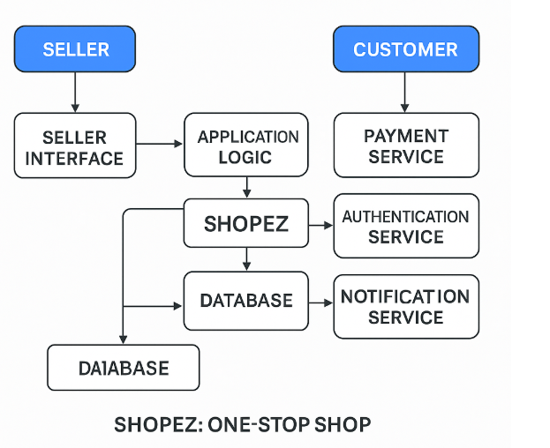

**User Stories**

**User Story Table – ShopEZ: One-Stop Shop for Online Purchases**

| **User Type** | **Functional Requirement (Epic)** | **User Story / Task** | **Acceptance Criteria** | **Priority** | **Release** |
| --- | --- | --- | --- | --- | --- |
| **Customer** | Product Browsing & Purchase | As a customer, I can search and filter products to find what I need. | Relevant products are shown based on search/filter. | High | Sprint-1 |
| **Customer** | Cart & Checkout | As a customer, I can add products to cart and complete payment securely. | Order is placed and payment confirmation received. | High | Sprint-2 |
| **Seller** | Product Management | As a seller, I can add, edit, and delete product listings. | Products appear on storefront after saving. | High | Sprint-1 |
| **Seller** | Order Management | As a seller, I can view and process incoming orders. | Orders update status upon confirmation/delivery. | Medium | Sprint-2 |
| **Admin** | Seller Moderation | As an admin, I can approve or reject new seller accounts. | Status change visible in the admin panel. | High | Sprint-1 |
| **User** | Authentication | As a user, I can sign up, log in, and reset my password securely. | Login success and token issued. | High | Sprint-1 |
| **Customer** | Reviews & Ratings | As a customer, I can leave a review after purchase. | Review appears under product after submission. | Medium | Sprint-3 |
| **Admin** | Platform Monitoring | As an admin, I can view all platform activity including sales, disputes, and reports. | Dashboard displays real-time analytics and actions. | Medium | Sprint-3 |